Game Design Document

Fill up the Following document

1. Write the title of your project.

Tank Shooter

1. What is the goal of the game?

**There are 2 levels in the game and they have their goals as 4000 and 10000 respectively.**

1. Write a brief story of your game?

**In my game, there is a tank(player) which is releasing bullets when the space key is pressed and from left-hand side some tanks are spawning which are releasing bullets and when the opponent** **bullet touches the player then the player’s life will deduct. And the player has 4 lives and when the life become 0 the game will end and if the score is greater than 4000 then the next level button will appear but if the score is less than 4000 then a restart button will appear. And in the next level the speed of spawning of tank and bullet will become high and if the score is less than 10000 then we will come back to first level and if the score is greater than 10000 then you will win this game.**

1. Which are the playing characters of this game?

* Playing characters are the ones which respond to the user based on the input from the user
* Cars, monkeys, dinos, wizards etc, are the playing characters in the game.

|  |  |  |
| --- | --- | --- |
| Number | Character Name | What can this character do? |
| 1 | Player Tank | It can release bullets to destroy enemy. |
| 2 | Opponent tanks | It can release bullets to decrease the player’s life |

1. Which are the Non Playing Characters of this game?

* Non Playing characters are the ones which don't have an action or a behaviour when the user interacts with the game.
* Hurdles, stones, bananas, coins, etc are non playing characters in the game.

|  |  |  |
| --- | --- | --- |
| Number | Character Name | What can this character do? |
| 1 | Lives | It will show the player’s life. |
| 2 | Score | It will decide that will the player go to the next level or not. |

Draw your imagination of this game. What does this game look like?

* Draw the game either on your computer or on paper,
* Add images of scenes of the game to show each of the playing and non-playing characters at least once.

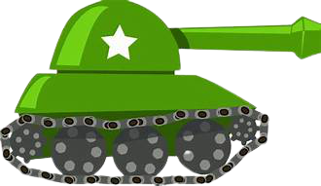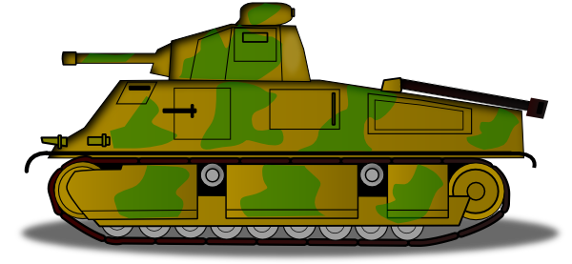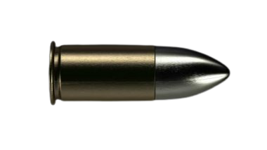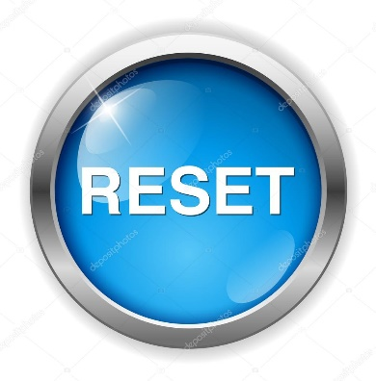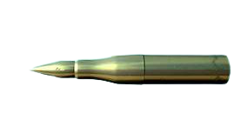

How do you plan to make your game engaging?

### I will **Make It Easy yet Addictive**

### I will **Create a Stunning Design**